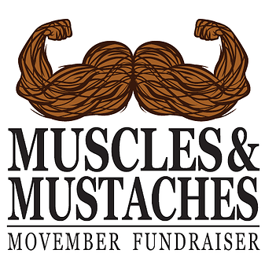
Return, with donation, to:

G+O Fitness
199 W Palmetto Park Rd, Suite F
Boca Raton, FL 33432

by Friday November 6, 2015
Sunday, November 29th
8:00 AM – 12:00 PM
G+O Parking Lot
199 W Palmetto Park Rd
Boca Raton, FL 33432

“Because a healthy man is a manly man!”
2015 Vendor Agreement
Business: ________________________________
Person of contact:__________________________
Address: _________________________________
City:_____________________________________
State:________ Zipcode: ____________________
Phone: __________________________________
Email: ___________________________________

MoBros and MoSistas,

We are so glad you have chosen to be a part of the 2nd annual Muscles & Mustaches Movember Fundraiser! This is going to be a great event for a great cause. We want lots of participation and spirit for this event, so encourage your staff, members, family and friends to come out, donate, and have fun with it! Please read the following notes and sign below.

- Vendor booths cost $300, please make the check out to Gravity Enterprises LLC, all proceeds will be donated to the Movember Foundation.
- All vendor booths are expected to be interactive (physical challenges, food, games, giveaways, etc.) how you choose to do this is completely up to you.
- All tables will be provided by Muscles and Mustaches. Tents and any other supplies will need to be supplied by the vendors themselves.
- Vendor location will be decided by the Muscles and Mustaches staff, this will be sent out to all vendors prior to the event.
- Vendors are expected to set up between 7:30 and 8:30 AM.

Name:_______________________Signature:____________________________

